**Excel Lecture-3**

* **OFFSET**



* + - For Example

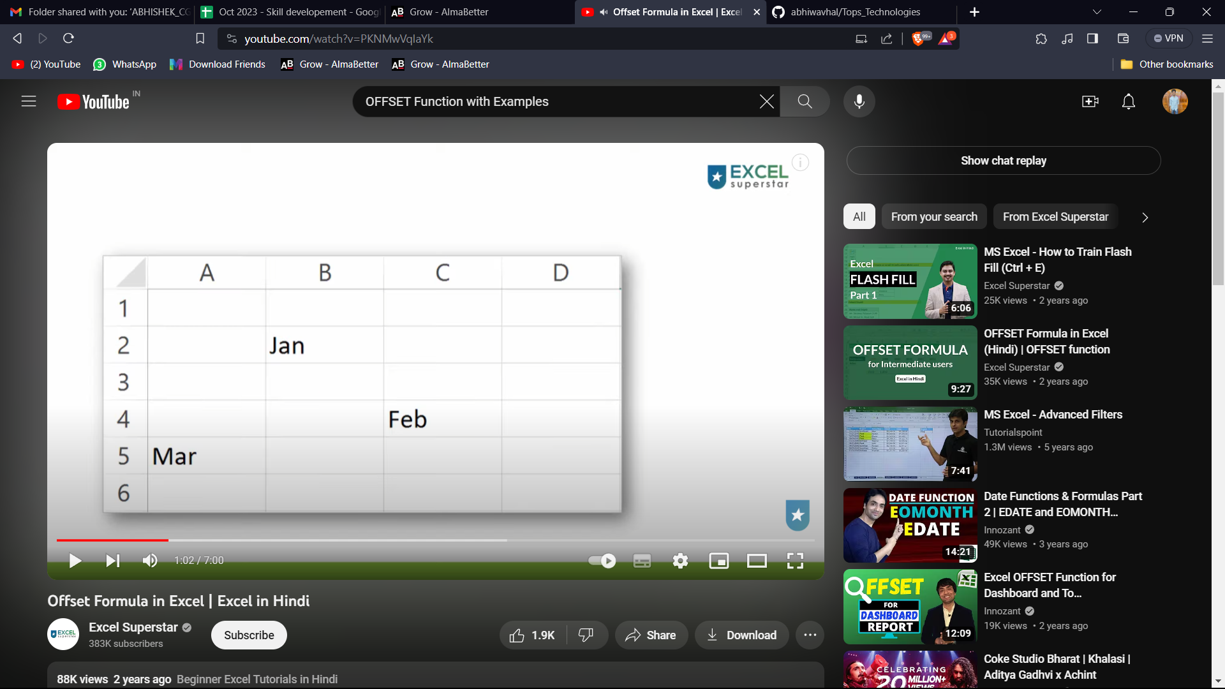

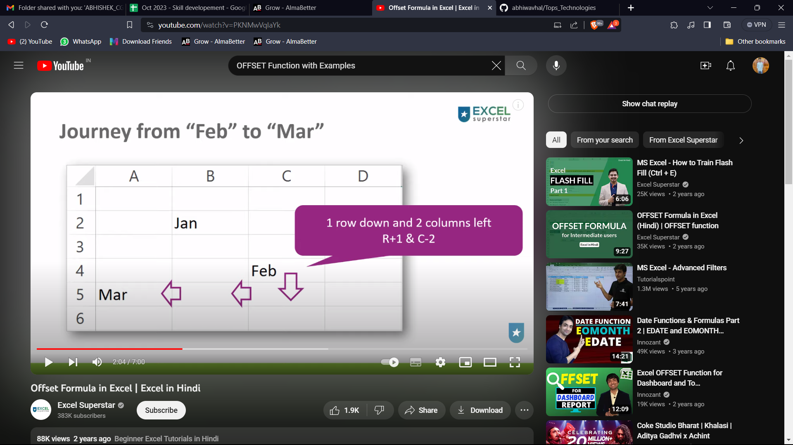

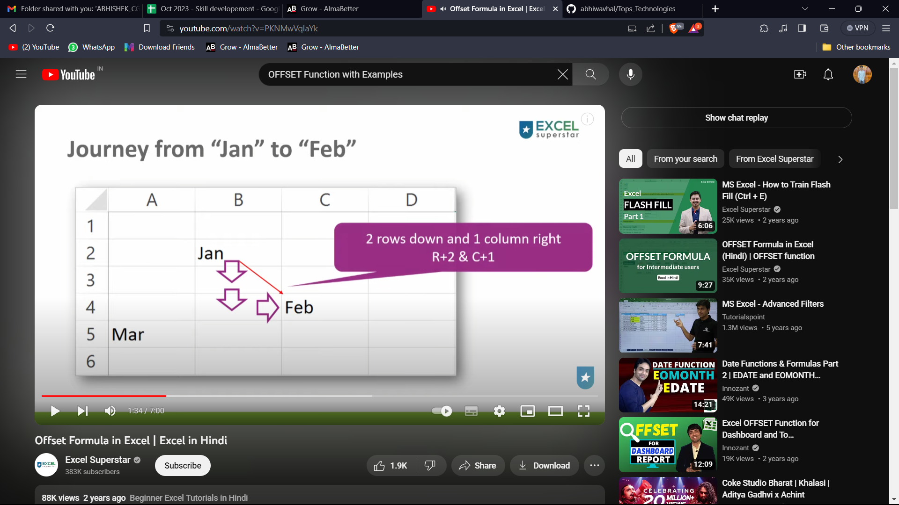

* + - Initial reference point is Jan
    - Revised Reference point is Feb



* **CHOOSE**
  + - Use
* **REMOVE DUPLICATES:**
  + - Remove Duplicate with Duplicate feature
    - Will Delete Original Data set
    - Unique Single column
    - Unique Table
* **Pivot Tables:**
  + - In Excel, a pivot table is a powerful data analysis and summarization tool used to organize and summarize large sets of data. It allows you to quickly and easily transform raw data into meaningful information by providing a way to create customized tables, charts, and reports.
    - Pivot tables are particularly useful when working with large datasets and when you need to quickly analyse, summarize, and visualize data in a flexible and customizable manner. They are widely used in business and data analysis to make sense of complex datasets and derive insights from them.